**T3D Micro Packs  
Master Server Installation**

Part 1: PHP Installation / MySQL Installation

This addon allows you to replace the existing master server listing system with a system controlled by PHP and MySQL.

First thing is first. You need to determine where on your website your master server will be located. You need to recall this location during part 2, so make sure you remember where it is (I’d recommend just using public_html so it’s [www.website.com/master/](http://www.website.com/master/), you’re free to change this as you wish). Inside the php folder of the new Master Server folder is a “master” folder. Upload this to your website. Inside the master folder is the myGame folder and the install.php file. We’ll get to install.php here in a minute.

On your web server, rename the myGame folder to something relevant to your project (you’ll need to remember the name of the folder). Now we need to do some MySQL work to create the necessary database. First find the location on your website where you can create MySQL Databases, a CPanel example follows:

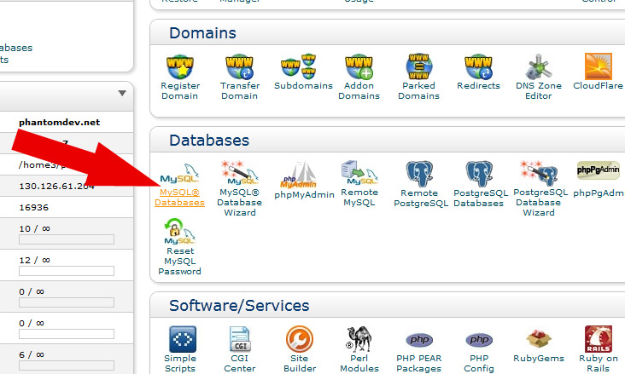

Now you need to create a new database. You may name it what you want, but you will need to remember its name for the install.php process. Once you create the new database, you will need to create a user that has access to the database.

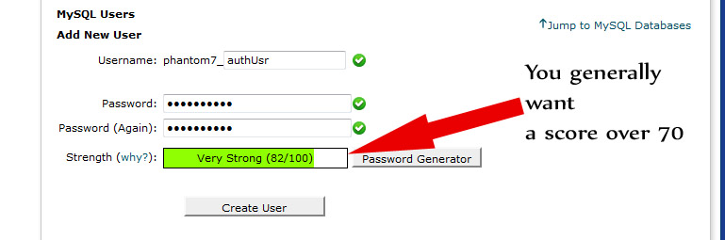

And then add your new user to your newly created database, giving your new user all permissions. Now with the pre-install work done, we can move on.

Open a web browser and navigate to the install.php file. Follow the five step process; this will generate the necessary tables and settings files for you. Once this is done, delete the install.php file on your web server (hold on to it locally, you may need it for another project in the future). You’re now done with PHP and MySQL, now let’s do C++.

Part 2: Library Installation and Pre-C++ work

This new system uses the cURL library to bypass needing Torque3D’s flawed TCPObject. In order to install the new library however, you need to make some edits to some existing T3D engine files to accomplish this. As of this version of MAP, the replacement files are that of T3D MIT 2.0, but no changes to these files have been made since then. If a case does come up in which these files are modified, a new version will be released that contains these adjustments.

To install the necessary files, copy and paste everything from the Engine folder to your own, replacing all existing files.

Lastly copy and paste the files from the tools folder to your own to add the module to the engine and re-generate your C++ project to include the new files. To add the module, you’ll need to open My Projects/[Your Project]/buildFiles/config/project.conf and add includeModule(‘MasterServer’); to the list of modules in the project, then use generateProjects.bat.

Part 3: C++ Code

First we need to tell the new system where the Master Server is located. Open PGD/Control/PGDMain.h and look for the line that defines the MasterServer variable. Point it to your website where the index.php file inside the folder you renamed in part 1 is.

Now we need to make a little adjustment to app/mainLoop.cpp. Start by scrolling down to the end of the #include statements, the last one reads:

// For the TickMs define... fix this for T2D...

#include "T3D/gameBase/processList.h"

Below that, add this code block:

#define _LOADPGDPMASTER 1

#include "PGD/Control/PGDMain.h"

Now scroll down to the definition of void StandardMainLoop::init() and after the block with Con::init(); add this block of code:

#ifdef _LOADPGDPMASTER

pgdServerQuery::create();

#endif

It should look something like this when done:

// Set up the resource manager and get some basic file types in it.

Con::init();

Platform::initConsole();

NetStringTable::create();

#ifdef _LOADPGDPMASTER

pgdServerQuery::create();

#endif

Once done, compile everything. If you get any linker errors relating to LIBCMT, simply add it to the list of ignored libraries and the engine should compile fine. Once it compiles, you’ve completed the hard stuff!

Part 4: Last Step, Adding TorqueScript Changes

You only need to do one thing to your actual game. Inside the TorqueScript folder is a replacement for the joinServerDlg.gui file. Simply replace your game’s one with the one in the folder (It’s just changing the function calls to use the newly defined ones), and you’re all done! Fire up your game and create a dedicated server. Click Query Master and enjoy seeing your server appear with your new PHP/MySQL solution behind it!